Concept Note on Cool Girls Online Radio

Introduction
One of the strategies of the Cool Girls program is to use innovative ideas and leverage technology to ensure easy and convenient access to information and facilitate discussions, providing Adolescent Girls and Young Women (AGYW) with a supportive environment to ask questions, share experiences, and engage interactively, fostering active participation.

The proposed Cool Girls Online Radio is a platform that will be seamlessly embedded into the existing Cool Girls Mobile application, with the intent to improve user engagement. This strategic incorporation aims to create a seamless and engaging environment that not only retains current users of the Cool Girls application but also has the potential to attract a wider audience. The Cool Girls Online Radio is a multi-layered approach that integrates live broadcasts, pre-recorded programs, an automated DJ player, interactive phoning segments, and a diverse range of music genres.

Key Features
1. Live Broadcasts: Live broadcasts will be the heart of Cool Girls Online Radio, offering real-time conversations, events, and interactions. These broadcasts will include:
- Talk Shows: Engaging discussions on topics ranging from career success and health to relationships and personal development.
- Live Events: Streaming special events, workshops, and relevant issues.
- Audience Participation: Interactive segments allowing listeners to call in, ask questions, and share their own experiences, fostering a sense of connection and community.
2. Pre-recorded Programs: Pre-recorded programs will offer a flexible way to deliver high-quality content while catering to diverse schedules:
- Themed Shows: Curated programs focusing on specific themes like entrepreneurship, arts, and wellness.
- Narrative Series: Serialized content, including inspirational stories, life lessons, and personal journeys.
- Educational Segments: Informative content, financial literacy, career advice, and more.
3. Auto DJ Player: The auto DJ player ensures seamless entertainment 24/7, even when live broadcasts and pre-recorded shows are not scheduled:
- Continuous Music: A handpicked selection of music representing various genres, moods, and cultures.

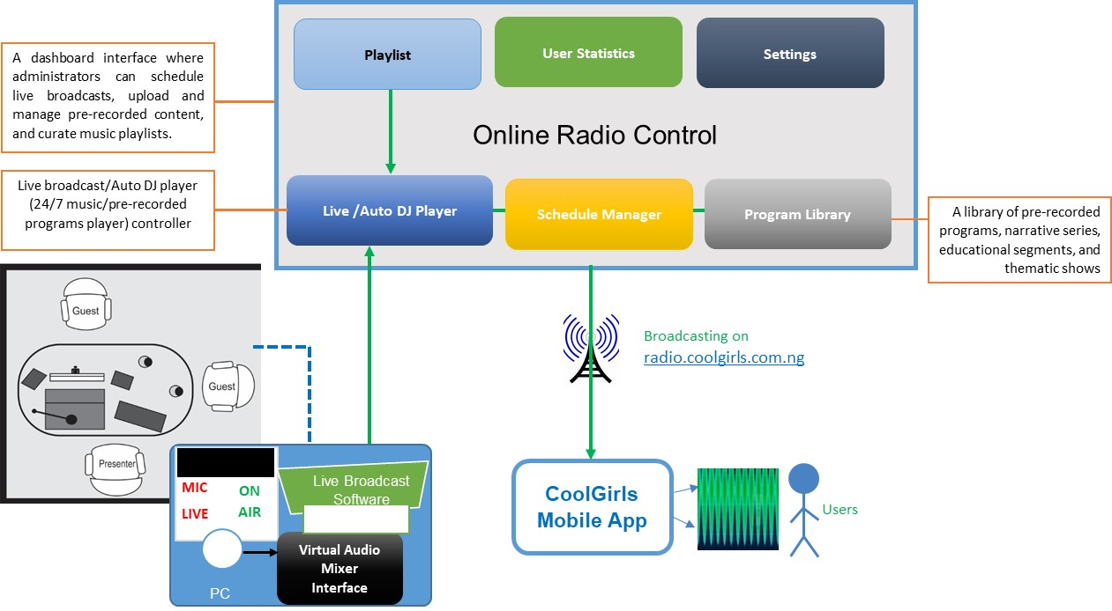
Fig 1: Architectural Overview
Implementation
The online radio platform will be hosted on the cloud to ensure seamless accessibility and scalability. It will be accessible through the sub-domain radio.coolgirls.com.ng, which is derived from the existing coolgirls.com.ng domain and will be integrated into the existing Cool Girls application.
Technical Infrastructure
- Cloud Infrastructure: A reliable cloud service provider to host the radio platform, ensuring scalability, high availability, and efficient resource allocation.
- Streaming Servers: Streaming servers capable of handling multiple concurrent listeners and providing seamless audio playback.
- Database Servers: Powerful database servers to store user preferences, content metadata, and engagement metrics.
Software Requirements
- Virtual audio mixer
- VB-audio virtual control panel
- Live broadcast software

Hardware Requirements
- Microphone Kit (Live broadcast)
- Laptop
- Digital Mixer
- Headphone
- Sound Card
Human Resources
- Content Creators: Skilled content creators responsible for developing engaging shows, pre-recorded programs, and curated music collections, among other things.
- System Administrator: Experienced system administrator to manage the cloud infrastructure, ensure smooth operations, and troubleshoot technical issues.

